  L1 sp23

Q1:

Software Requirements Specification

for

FPT University Academic Portal

Version 1.0 approved

Prepared by

DOAN TUAN KHAI – SE172498

FU Ho Chi Minh

24/07/2023

Q2:

<Answer Q2 by drawing 1 use case diagram that reflect this exam paper and copy and then paste the image of that use case diagram here >

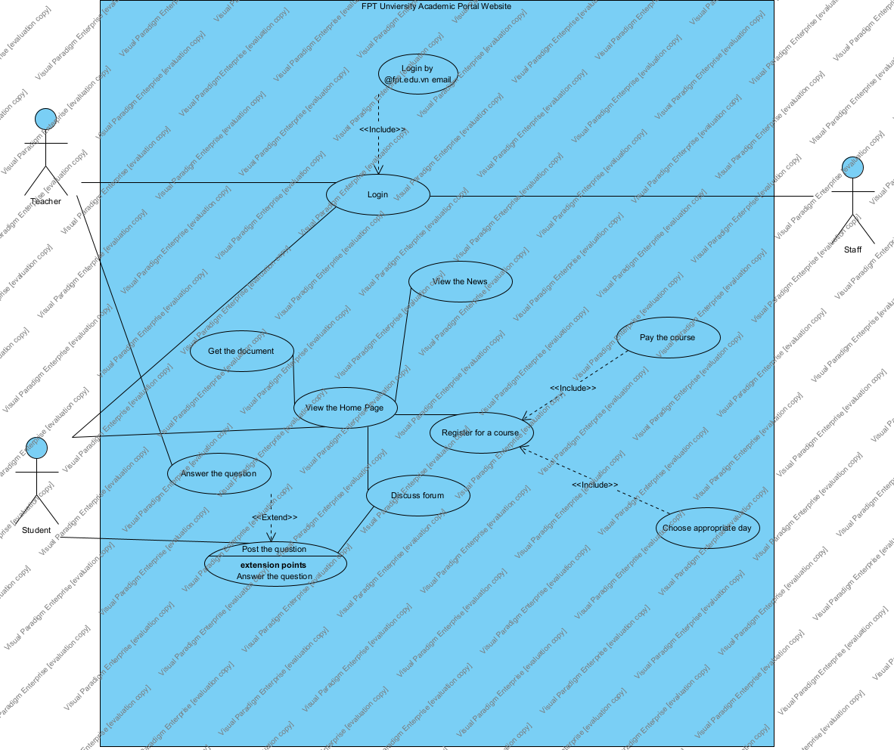

Q3: <Answer of Q3 by fill the content to below table that reflect this exam paper>

|  |  |  |  |
| --- | --- | --- | --- |
| UC ID and Name: | Register the courses | | |
| Created By: | Khaidtse172498@fpt.edu.vn | Date Created: | 24/07/2023 |
| Primary Actor: | Student | Secondary Actors: | None |
| Trigger: | The student want to add the course | | |
| Description: | Describe the process the student register for courses | | |
| Preconditions: | 1. The student must login with @fpt.edu.vn email to register the course 2. The student must have enough balance in their e-wallet 3. The student register in time(the course is available date) | | |
| Postconditions: | 1. The student can go to “See registered course” to see if their courses have been successfully added. 2. The student can view the timetable to see their course. | | |
| Normal Flow: | 1. The student choose the course 2. The student choose the time that appropriate for their timetable. 3. Click button “Add” to add the course | | |
| Alternative Flows: | 1. Choose the course available 2. Put the courses in the whilst if courses are not available. | | |
| Exceptions: | 1. The student does not have enough balance in the wallet 2. The course has been out of date 3. The course has been fully registered by other student | | |
| Priority: | High | | |
| Frequency of Use: | Medium | | |
| Business Rules: | BR1: The course can not be duplicated | | |
| Other Information: | None | | |
| Assumptions: | Student may have different payment for the course, such as e-wallet, banking, debit/credit cards, cash. | | |

**Q4:** <The answer of Q4 must have detail and specific in number of 2 non-functional requirements>

First non-functional: Allow the website for about 100 students can access in. Some of them may access to the website to register for a course, to see the news, to see timetable,… in a same time.

Second non-functional: Give the student time out for after 30 minutes if the student do nothing for the website. Then end the session to log out the account.